Project summary
URGENT aims to promote green & blue infrastructure and nature-based solutions (GBI&NBS) for resilient, climate-friendly and liveable cities in IN & MN (partner countries – PCs) through ICT-enhanced tertiary education linked to labour markets & wider stakeholder circles. This aim will be achieved through the following objectives:

1. To upgrade GBI&NBS -relevant BSc, MSc & PhD programs at PIs to make them end-user-oriented & policy-relevant. A pool of URGENT e-courses will be tailored to fit educational needs of learners from science, engineering & planning (154 ECTS of new and updated subjects openly available via e-learning). An URGENT research framework will outline internationally- & policy-relevant research topics, questions & methodology suggestions.

2. To develop shared UREGENT Collaborative Learning Platform & online training services of the new generation for qualitative improvement of the education process & academic workflow support among universities & stakeholders (URBAN_learn).

3. To create sustainable feedback mechanisms to end-users, ensuring adaptive & practice-relevant teaching contents, knowledge co-production opportunities and stakeholder support to post-project course development & teaching. URGENT stakeholder interactive platforms (SIPs) in PCs will assemble representatives of praxis communities involved to GBI&NBS issues. SIPs will be platforms for academia to disseminate innovative ideas, visions of the future and inform evidence-based management, while praxis partners contribute with their in-hand experiences & know-hows, review curricula, participate QA mechanisms & support graduates’ entry to workplace.

4. To develop capacity for academic mobility, shared experimental facilities and joint research by PIs & beyond. URGENT partners will institutionalise their relationship through framework agreements, and set-up rules for physical & virtual mobility, joint research & thesis supervision and common use of research & experimental facilities.

2. Project objectives
1. To revise and upgrade selected GBI&NBS -relevant BSc, MSc & PhD programs in PIs to make them end-user-oriented & policy-relevant, and develop 6 modules addressing GBI&NBS-related hotspots, that can be used interchangeably in tertiary & LLL education.

Successful delivery of objective 1 will result in a pool of e-courses, with each of the 6 URGENT cross-cutting themes (see D1) covered by courses tailored to fit educational needs of learners from science, engineering & planning, but also from bachelor’s & master’s levels (75 ECTS of new and updated disciplines in IN & 39 ECTS in MN) enrolled to academic programs at PIs & beyond. We expect that the courses also will be picked up by doctoral students, however we only lightly touch them, as PhD studies in IN & MN do not include substantial training components. Each course will be openly available via e-learning and accompanied by original learning materials (including syllabi, assignment descriptions, lecture notes, as well as interactive elements and videolectures for selected courses), case study databases & reading; except HEI learners, they also will be advertised to formal & informal LLL learners. The thematic relevance, broad scope, and fit to the demands of target audiences will be secured through the diversity of academic institutions in PCs involved in curricula-development (science, engineering & management departments operating in different socio-political contexts), input of high profile expert support from EU partners as well as engagement of stakeholders from the world of praxis (in planning, development, piloting & review stages). Dissemination of the curriculum offer within URGENT and beyond, and easy pick-up by faculty & student will be ensured by URGENT e-learning. Core deliverables also include URGENT research framework based on in-depth analysis of partners’ (i.e. both PCs & institutions) research objectives, profiles & capacities, and outlining internationally- & policy-relevant research topics, questions & methodology suggestions.

2. To develop shared UREGENT Collaborative Learning Platform & online training services of the new generation for qualitative improvement of the education process & academic workflow support among universities & stakeholders across the PCs & EU.

Tangible outputs include a suite of URGENT e-learning & e-science services (URBAN_learn) that in part will be a standing alone service, and in part a webgate to dedicated URGENT sections in e-learning systems of partner institutions. It will provide free access to URGENT contents, including courses, case study databases & summary modules with interactive & video contents introducing 6 cross-cutting URGENT themes and supporting blended learning. URGENT PhD students & their supervisors will have access to tailored e-science modules providing planning services & quick access to important information.

3. To create sustainable feedback mechanisms to end-users, ensuring adaptive & practice-relevant teaching contents, knowledge co-production opportunities and stakeholder support to post-project course development & teaching.

The tangible output is established URGENT stakeholder interactive platforms (SIPs) in IN & MN assembling representatives of praxis communities involved to GBI&NBS issues. Their aim is to create “communities of practice”, where academia would disseminate innovative ideas, visions of the future, inform evidence-based management, and offer flexible LLL trajectories, while praxis partners enhance educational provision with their in-hand experiences & know-hows, review curricula, participate QA mechanisms & support graduates’ entry to workplace.

4. To develop capacity for academic mobility, shared experimental facilities and joint research by PIs & beyond.

URGENT partners will institutionalise their relationship through framework agreements, and set-up rules for physical & virtual mobility, joint research & thesis supervision and common use of research & experimental facilities; the latter will be also supported by an updatable catalogue of such facilities available at each PI.

In INDIA the objective 1 address the overall problem of severe underfunding that constraints any efforts to update curricula, as faculty members are overworked, underpaid and miss training opportunities, whereas with curriculum development time partly co-funded from the project, and with expert support from EU colleagues & from elsewhere within URGENT (including both regular training events as well as practical placements, one-off consulting visits & co-teaching), new quality contents (including the research training framework) will be developed and piloted. This problem is further addressed by the objective 2, as it will help to set-up e-learning systems and upgrade classroom equipment in HEIs that could not be expected otherwise, by the objective 3 that supports (through co-funded work time, travel & expert advice) work on engaging praxis representatives, and by the objective 4 that will mitigate the financial burden through provisions for virtual mobility, smoothing physical mobility and arrangements for equipment sharing across URGENT.

In MONGOLIA, with its problem of underfunding in HEIs equally persistent, although somewhat less grave, the ways the objectives 1-4 address it are the same.

In INDIA objectives 1-3 further address the problem of poorly developed emerging competences demonstrated by graduates entering workplace with an URGENT-related range of tasks, as well as low awareness of the latest international science & policy developments. The impact of the objective 1 is through new tailored to fit and adaptive course offer built on the latest policy- developments and cutting edge science, the objective’s 2 is through ICT-enhanced learning experience and broader course offer available from the partnership via e-learning, and the objective’s 3 through enhanced engagement of stakeholders to curriculum development & teaching.

In MONGOLIA the objectives 1-3 will work the same way in addressing the problem with the quality of expertise needed to implement its green growth agenda, in particular where it comes to the expertise of engineers & managers with non-environmental backgrounds, and who are involved to URGENT-related issues. Here the diversity of URGENT course offer secured through the deliverables of the objectives 1 and 2, blended learning environments planned under the objective 2, and institutionalised engagement with the world of profession planned under the objective 3.

Both in INDIA & MONGOLIA the objectives 1-4 address the problem of HEIs’ visibility and of the quality of applying students through attractive course offers appreciated by employers (1 and 3), close engagement with the world of profession (3), state of the art e-learning & classroom facilities (2), and attractive mobility & regional cooperation options (4).

The set objectives are realistic and feasible in institutional and national contexts because they were brought up as a result of an iterative process involving all the URGENT PIs and other relevant stakeholders. The objectives account for timelines and requirements of institutional & national accreditation (e.g. we purposefully did not plan for new academic program, as not feasible in IN & MN within the CBHE time frame), institutional & national financial & tendering rules, existing institutional expertise (i.e. specific people behind curriculum proposals) and ICT capacity, but also for institutional development strategies. The identified gaps will be addressed by training events, curriculum co-development, equipment acquisition, co-funded work time etc.

Management structure and procedures

3.1 Structure
Bilateral Partnership Agreements (PA) were concluded between the Coordinator and each of the project Partners, i.e. total of ten (15) PA. The bilateral form was preferred as it refers to a particular Partner, clearly regulating only its relations with the Coordinator. The texts are identical, but the Annex with the financial issues: Budget break down and Payment plan is individual for each partner.
The template was developed by UniHB, approved by Legal department of the coordinator and then approved by the legal departments of the partners. All the agreements were signed in February 2019.
The Project Structure and management tasks:
- Distribution of tasks and activities;
- Communication and Support;
- Setting and Monitoring Deadlines;
- Collection of Progress and Financial Reports;
were defined and agreed during the Kick-Off meeting in March 2021.
The project coordinator works together with the coordinators for India and Mongolia, as well as with the WPs leaders.
A supervising Steering Group (SG) composed of WP leaders and project manager was set. The Steering Group monitors the strategic issues of the project and ensures to maximise project benefits by coordinating main activities of the project and review progress and quality control of results.
URGENT project is organised in 7 Work Packages (WP). WP leaders and activities leaders are defined in Workplan. Workplan is revised at SG Meetings. SG meetings are hold at least each ½ year, via Videoconferencing.

3.2 Key Indicators
We use key indicators established in LFM as progress indicators.
Most important indicators are: number of developed courses, textbooks and guidelines, eLearning modules, workshops, publications, participants of the summer school, students studying according to the new TLM, reports.
Schedule and budget compliance, quality of deliverables are important indicators that are monitored by QAT and PM.

Project communication
All project members communicate via Email, using the prepared mailing list. WP leaders initiate the online meetings to discuss the work on the activities, if necessary. The joint meetings are hold in English language. English is also standard language for the reporting. National coordinators organize the local meeting (life and online) to discuss some general national issues (Accreditation procedure for Syllabi and Curricula, national rules for purchase of equipment, etc.)
Online meetings (SKYPE) are hold often mostly bilateral – PM-LPM at least once a week, all LPMs (via Video conferencing systems 1 time a month). Coordinator Monitoring visits are combined with the SHG meetings that are hold by the partner universities. Communication tools: Email, Skype for common use and meeting between 2-5 partners, Video conferencing tolls (ZOOM, Big Blue Button) for the meetings with more participants. SG meetings are hold each ½ year.
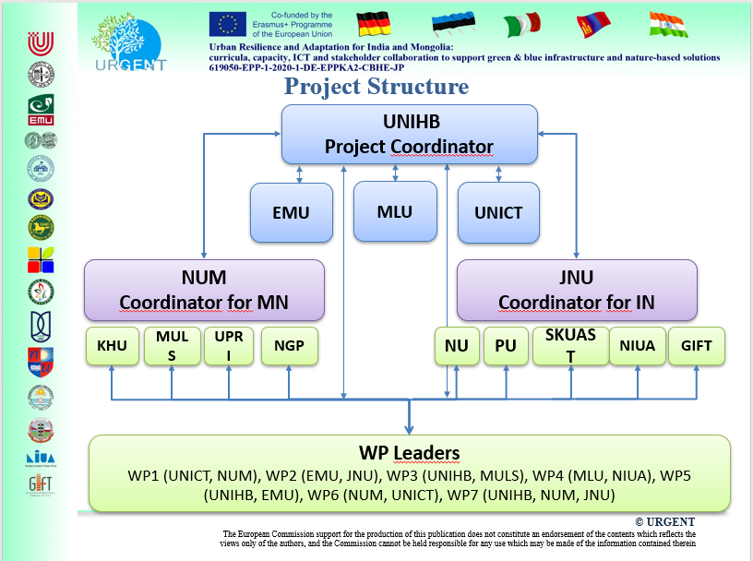

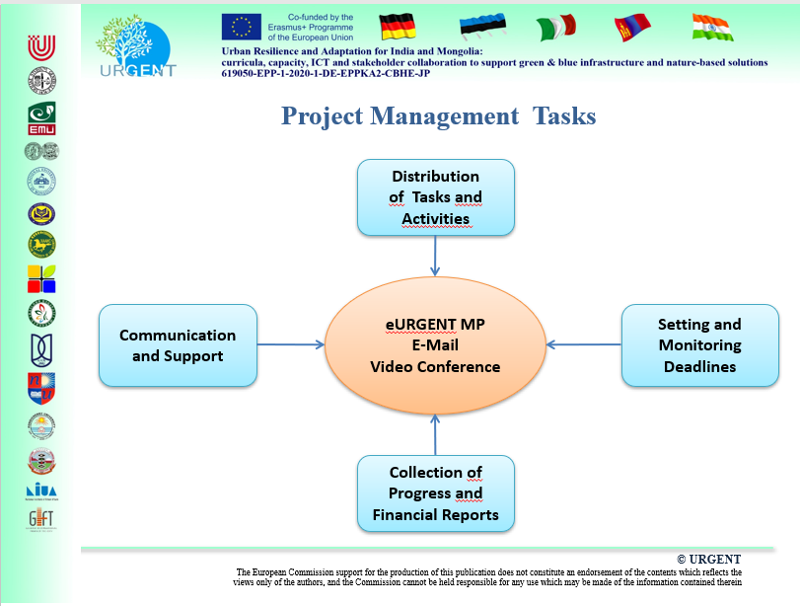

Project meetings
Kick Off Meeting Online
1,5 UNICT (Catania)
Final JNU (New Delhi)

Management of the grant
The grant is administered by the coordinator UniHB. The rules applicable to management of the Erasmus+ grant were presented to partners in detail (by budget heading) at the kick-off meeting, which all the Local Project Managers have attended. The presentation was based on Guidelines for Use of the Grant, and on the experience of the completed Tempus IV project. The UniHB financial regulations and the approach to harmonise those with Erasmus+ rules were explained in detail at the same meeting by the URGENT financial manager, experienced in EU projects, including Erasmus+.
The special document, summarizing all supporting documents for different budget headings was prepared. The partners got the information from Project Representatives Meeting in Brussels. Before the Kick Off meeting, the coordinator prepared the overview of the activities and overall Budget for all partners. It was agreed during the Kick Off meeting and distributed to the partners.
According the partner agreement and it Annexes, the whole project time is divided into six ½ year payment periods. The three or four payments (Depending on the equipment needs) to the partners are planned. The last one will be payed after the last payment from EACEA.
The first payment was payed after the conclusion of the Partner agreement as prepayment for the travel costs and costs of stay, as well as for the staff costs. In the begin of the reporting period, the Financial Manager supplies the partners with the templates for the reporting, where all planed tasks for the reporting period are listed. After the end of the payment period partners deliver Joint Declarations, Time Sheets, Individual Travel Reports and all supporting documents. They also provide the Excel Sheet for financial statements. The Financial manager proves them, fills the common financial statement sheet for the financial report and check if costs differ from the planned. If the financial manager approves the financial report for the payment period, it is given to the UniHB financial department, where it is proved again. After it the next payment to the partner is done. The next payment covers the staff costs for the fulfilled activities and include prepayment for the Mobility, purchase of Equipment.
The partners get the summery of the approved financial reports back.
Reimbursement of Travel costs and costs of Stay follows the following the following principles:
• When planning a travel a beneficiary aims not to exceed the defined unit costs amounts;
• Travel costs and costs of Stay are reimbursed according the unit costs;
• Overspendings or savings in respect to the unit costs amounts are registered by LPMs;
• Steering Group decides on the best way of dealing with overspendings or savings, following the principle of maximum benefit for the project.

Project management platform
The instance of the OMSE platform was set for the project Management. It provides different tools for the management: Workplan, Schedule, Resource sharing, Announcements, Polls, etc.
Special sites were developed for the Dissemination activities and Quality Control.
The special project management platform is based on OMSE Sakai.
It includes the work plan, schedule, and resources tool.
The platform includes special sites for the Quality Control and Dissemination activities.
The project coordinator set this platform at the begin of the project; all participants can use it to get the necessary information when required. The work plan describes all activities, deadlines and responsible partners. The schedule gives an overview of the activities, their start dates and deadlines.
WP Leaders upload the Reports and developed materials in the Resources tool. The quality control manager regularly checks the materials, fills the Quality Matrix and writes quality evaluation reports.
If there are no reporting documents until the due date, Quality Manager writes a reminder to the WP leader and informs project coordinator.
Guidelines for the use of the grant are also available in the platform and can be used for preparing the supporting documents. More details to the platform are listed in the special document Project management platform.

