REPORT FOR TRAINING ON HOW TO DEVELOP TLM AND VIDEO LECTURE
Tuesday, 13 September 2022, 05:00 pm – 06:30 pm

Title: | Urban Resilience and Adaptation for India and Mongolia: curricula, capacity, ICT and stakeholder collaboration to support green & blue infrastructure and nature-based solutions – URGENT
Number: | 619050-EPP-1-2020-1-DE-EPPKA2-CBHE-JP
Coordinator: | National University of Mongolia
Participants: | Mongolian University of Life Sciences  Khovd University  Urban Planning and Research Institute  National Garden Park of Ulaanbaatar

Objectives of the training:
- To introduce how to develop teaching-learning materials and video lecture

Date: Tuesday, 13 September 2022, 05:00 pm – 06:30 pm
Venue: Online using Microsoft Teams

Schedule:
Time | Topic | Presenter
17:00-17:10 | Regulation on e-course | O.Altansukh, NUM
17:10-17:40 | TLM preparation
17:40-18:10 | Develop video lecture using Power point software
18:10-18:20 | Preparation of reading materials
18:20-18:30 | Preparation of assignment and test pool
18:30-19:00 | Q&A and open discussion

The national coordinator (NUM-P5) of the URGENT project has organized the technical training on TLM and video lecture creation using simple tools for the Mongolian team on 13th September 2022 between 5 and 7 PM. All team members (12; f-9, m-3) who are responsible to develop the e-course module have participated. During the training, the followings are explained and taught.
- A regulation on e-course development has been explained.
- Template for teaching and learning material is explained.
- Reading materials and test pools are explained and shown in actual case.
- Most importantly, how to make a video lecture using Power point software is shown.

Participants:
№ | Full name | E-mail | Organization
 | Altansukh Ochir | altansukh@num.edu.mn | National University of Mongolia
 | Altanzul Davaa-Ochir | altanzul@toc.mn | Mongolian Sustainable Finance Association
 | Banzragch Dalai | banzragch@muls.edu.mn | Mongolian University of Life Sciences
 | Belguun | belguun@muls.edu.mn | Mongolian University of Life Sciences
 | Enkhchimeg. B | enkhchimeg@seas.num.edu.mn | National University of Mongolia
 | Monkhtuvshin | monkhtuvshin@muls.edu.mn | Mongolian University of Life Sciences
 | Odongerel Sangidorj | odongerel@muls.edu.mn | Mongolian University of Life Sciences
 | Oyunchimeg N | n.oyunchimeg@num.edu.mn | National University of Mongolia
 | Unurnasan Dagva | unurnasan@khu.edu.mn | Khovd University
 | Amarjargal Ayurzana | amarjargal@khu.edu.mn | Khovd University
 | Uranbaigal | info@upri.ub.gov.mn | Urban Planning and Research Institute
 | Ariunsanaa Bat-Erdene | ariunsanaa@seas.num.edu.mn | National University of Mongolia

The training video record: https://youtu.be/eZ2BElc3BNs

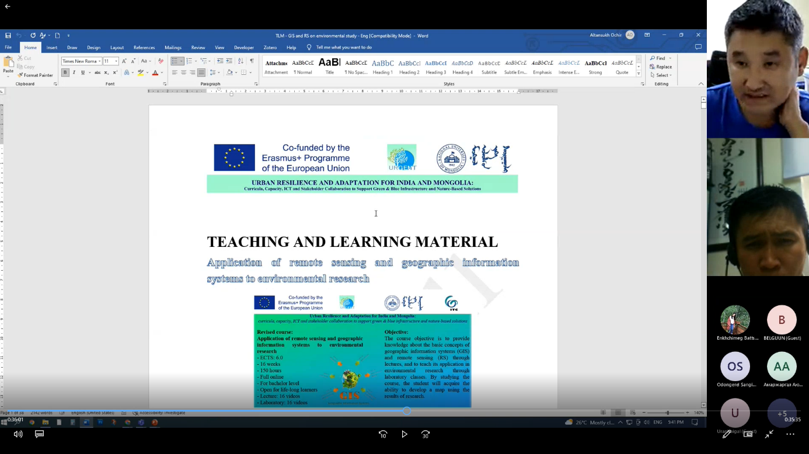

Reported by Ochir ALTANSUKH, National University of Mongolia

