Virtual meeting of Mongolian team about how to revise/develop e-courses

The national coordinator of the URGENT project has been organized the virtual meeting on how to revise/develop e-courses on 4th October 2021 between 4 pm and 5:30 pm. Three HEIs have been participated. All steps to create online course and to embed it in the OpenEDX platform process is explained.
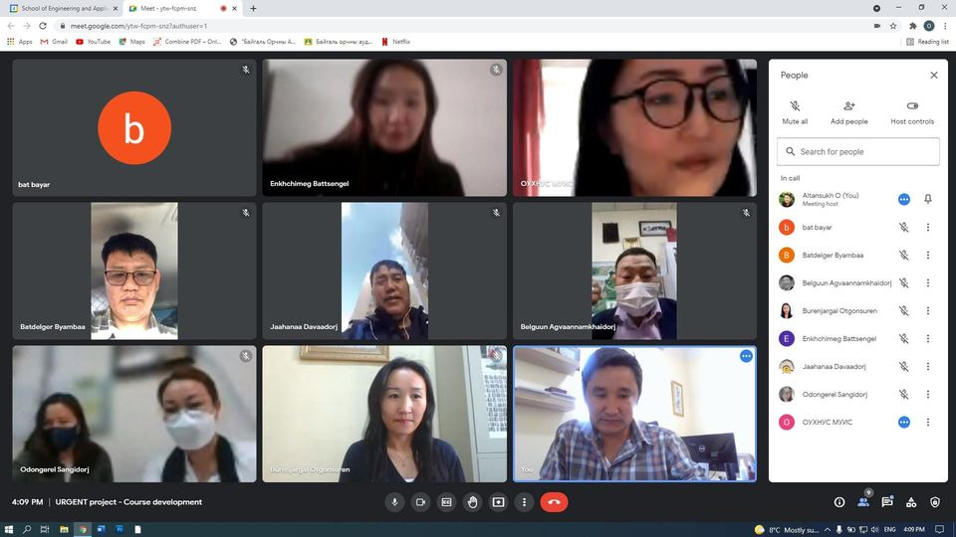

Reported by Ochir ALTANSUKH, National University of Mongolia

